# CS 255 System Design Document Template

Johnny Vu

CS 255

## UML Diagrams

### UML Use Case Diagram

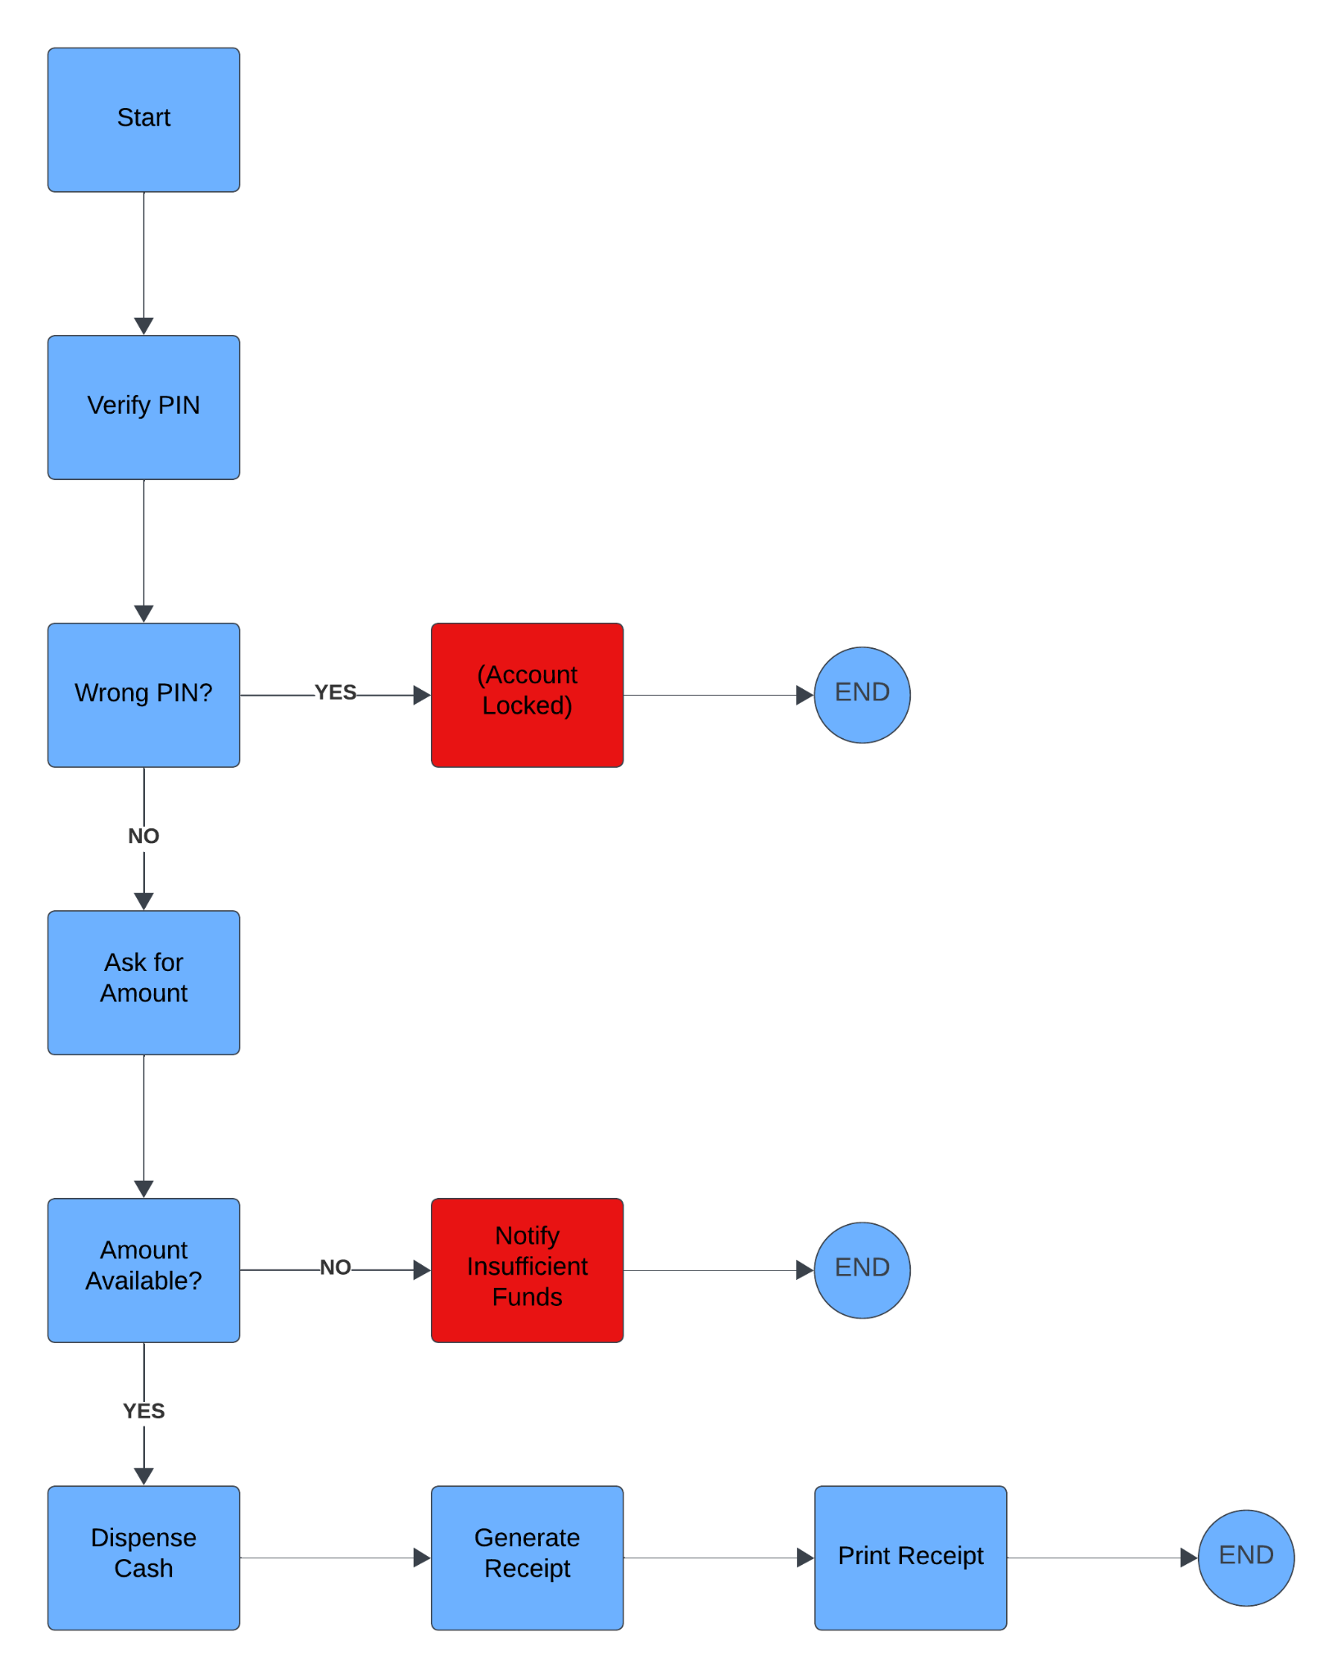

### UML Activity Diagrams

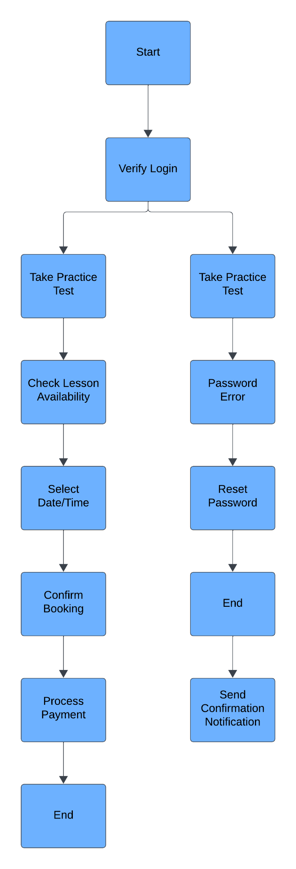

### UML Sequence Diagram

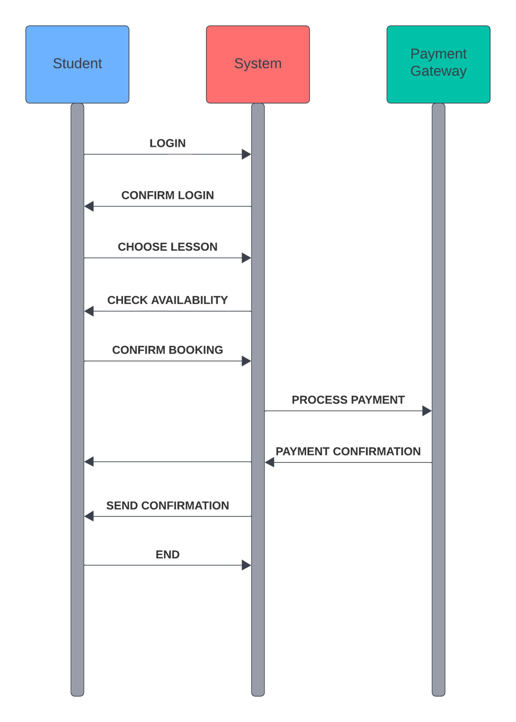

### UML Class Diagram

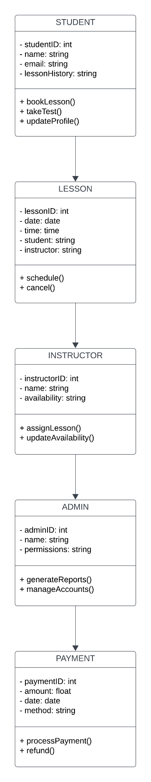

## Technical Requirements

The DriverPass system requires robust hardware infrastructure, including web servers to host the application, database servers for storing student data and lesson schedules, and backup servers for data protection. The system should be accessible through modern computers and mobile devices, supporting various browsers for responsive use. Cloud services, such as AWS or Google Cloud, will provide scalable hosting, ensuring the system can handle increased demand as the business grows.

For software requirements, the system should be built using a reliable web framework like Node.js or Django, with a dynamic front-end built on React or Angular. The system will use a relational database (e.g., MySQL or PostgreSQL) to manage student data and scheduling, with integration to a third-party payment gateway like Stripe or PayPal for secure transactions. SSL/TLS encryption will secure communications, and two-factor authentication will be required for admins and instructors.

In terms of tools, Lucidchart or similar CASE tools will be used for diagramming, while GitHub will support version control for development. Security will be paramount, with firewalls, Intrusion Detection Systems (IDS), and encryption libraries protecting sensitive user data. Postman will be used for API testing, ensuring smooth integration with external systems, like the DMV.

For infrastructure, the system will be designed to scale with the business, ensuring performance during peak traffic times through load balancers and auto-scaling features. Cloud hosting services will provide high availability, while disaster recovery measures, including automated backups, will safeguard critical data. Regular system backups and API integrations will ensure compliance with the latest driving regulations, keeping training materials up to date.